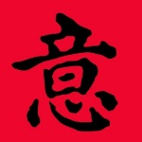

www.fengshuiconnections.com Mobile/text: 603-867-4347

Five Element Audit Worksheet

Date: Room: Bagua Sector:
Wood energy is represented in my space by trees, plants and flowers, blue, green, vertical stripes, columns:
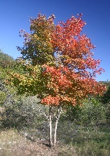
This Photo by Unknown Author is licensed under CC BY-SA
Fire energy is represented in my space by fireplace, stove, electronics, electrical items, people and animals, triangles, cones and pyramids, sunlight, lights, candles:
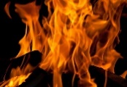

Earth energy is represented in my space by: low, heavy furniture, wood objects, wooden furniture, squares, horizontal rectangles, long flat surfaces, yellow, brown, earth tones, brick, pottery, seashells:
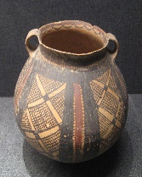
This Photo by Unknown Author is licensed under CC BY-SA

Metal energy is represented in my space by: all metals (gold, aluminum, brass, stainless steel, etc.) white, gray and pastel shades, rocks and stones, circle, oval and arch shapes:
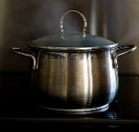
This Photo by Unknown Author is licensed under CC BY-ND

Water energy is represented in my space by: water and water features, glass,
This Photo by Unknown Author is licensed under CC BY-SA
Elemental Combinations:

Adjustments I’d like to make:

